TOWN OF FALLSBURG
INTRODUCTORY LOCAL LAW
REZONING OF A PORTION OF PLANNED UNIT DEVELOPMENT DISTRICT NO. 1

BE IT ENACTED by the Town Board of the Town of Fallsburg, County of Sullivan, State of New York, as follows:
Section 1. Legislative intent. The Town Board has been informed by the Town’s professional planning consultant that portions of the boundary of the Planned Unit Development District No. 1 (“PUD 1”) shown on the Town’s zoning map are not correct. Correction of the zoning map will reduce the area of the PUD 1 District. The land area, and properties, that will no longer be located within the PUD 1 District will be rezoned to the Hamlet Residence (HR) zoning district, which is the same zoning district as the land adjoining the current PUD 1 District and is consistent with the Town’s Comprehensive Plan.
Section 2. The Zoning Map of the Town of Fallsburg, authorized pursuant to §310-3.2, titled “Zoning Map,” of Chapter 310, titled “Zoning,” of the Code of the Town of Fallsburg is amended by reducing the area of the Planned Unit Development District No. 1, which amended area is described in the metes and bounds description annexed hereto as Exhibit A and shown on the portion of the Zoning Map annexed as Exhibit B.
Section 3. Section 310-19.1 of Article XIX, titled “Planned Unit Development District No. 1,” of Chapter 310, titled “Zoning,” of the Code of the Town of Fallsburg is amended by changing the title of the PUD 1 District from “Lakeside Acres Planned Unit Development District” to “Luxor Jr. Planned Unit Development District.”
Section 4. The area, and properties, that shall no longer be located within the PUD 1 District shall be rezoned to the HR (Hamlet Residence) zoning district, as listed in Exhibit C annexed and shown on the portion of the Zoning Map annexed in Exhibit B.
Section 5. Severability. The provisions of this local law are severable and if any provision, clause, subsection, sentence, word or part thereof is held illegal or invalid, or inapplicable to a person or circumstance, such illegality, invalidity or inapplicability shall not affect or impair any of the remaining provisions, clauses, subsections, sentences, words or parts of this local law of their application to other person or circumstance. It is hereby declared that the legislative intent of the Town Board is that this local law would have been adopted if such illegal or invalid provision, clause, subsection, sentence, word or part had not been included therein and if such person or circumstance to which the local law or part thereof is held inapplicable had been exempted therefrom.
Section 6. This local law shall take effect immediately upon filing in the office of the Secretary of State.

EXHIBIT A
METES AND BOUNDS DESCRIPTION
LUXOR JUNIOR PLANNED UNIT DEVELOPMENT
TOWN OF FALLSBURG, SULLIVAN COUNTY, NEW YORK STATE
ALL THAT TRACT OR PARCEL OF LAND situate in the Town of Fallsburg, County of Sullivan and State of New York, being TM# 12.-1-41.5 bounded and described as follows:
BEGINNING at a point on the division line between TM# 12.-1-9.1 on the north and TM# 12.-1-41.5 on the south at its intersection with the division line between TM# 12.-1-41.4 on the west and said TM# 12.-1-41.5 on the east;
RUNNING THENCE along the last mentioned division line the following four (4) courses and distances:
1) S60°16’07”E, a distance of 102.29 feet to a point;
2) S60°39’42”E, a distance of 162.59 feet to a point;
3) S62°12’02”E, a distance of 297.12 feet to a point;
4) S64°26’51”E, a distance of 79.20 feet to a point at its intersection with the division line between TM# 12.-1-38 on the southeast and said TM# 12.-1-41.5 on the northwest; thence along the division lines between said TM# 12.-1-38 and said TM# 12.-1-41.5 the following four (4) courses and distances:
1) S33°00’58”W, a distance of 102.00 feet to a point;
2) S19°52’04”W, a distance of 28.41 feet to a point;
3) S27°26’47”W, a distance of 215.19 feet to a point;
4) S29°07’53”W, a distance of 191.85 feet to a point at its intersection with the division line between TM# 12.-1-37 on the southeast and said TM# 12.-1-41.5 on the northwest; thence along the last mentioned division line the following three (3) courses and distances:
1) S29°36’21”W, a distance of 234.25 feet to a point;
2) S27°22’20”W, a distance of 171.45 feet to a point;
3) S28°47’52”W, a distance of 250.52 feet to a point at its intersection with the division line between TM# 12.-1-39.3 on the southeast and said TM# 12.-1-41.5 on the northwest; thence along the last mentioned division line the following five (5) courses and distances:
1) S29°40’18”W, a distance of 113.83 feet to a point;
2) S28°05’03”W, a distance of 179.71 feet to a point;
3) S30°52’12”W, a distance of 159.53 feet to a point;
4) S26°32’59”W, a distance of 45.21 feet to a point;
5) S27°50’36”W, a distance of 289.39 feet to a point at its intersection with the division line between TM# 19.A-10-18 on the southwest and said TM# 12.-1-41.5 on the northeast; thence N60°55’20”W along the last mentioned division line and along the northeasterly lines of TM# 19.A-10-17, TM# 19.A-10-16, TM# 19.A-10-15, TM# 19.A-10-14, TM# 19.A-10-13, TM# 19.A-10-8, TM# 19.A-10-7.2, TM# 19.A-10-6, TM# 19.A-10-5 and TM# 19.A-10-4, a distance of 961.32 feet to a point at its intersection with the division line between TM# 19.A-10-3 on the southeast and said TM# 12.-1-41.5 on the northwest; thence S28°58’57”W along the last mentioned division line and along the northwesterly line of TM# 19.A-10-2, a distance of 249.88 feet to a point at its intersection with the division line between TM# 19.A-10-1 on the southwest and said TM# 12.-1-41.5 on the northeast; thence N61°04’47”W along the last mentioned division line and along northeasterly boundary of Lakeside Drive/Gail Drive, a distance of 143.28 feet to a point at its intersection with the division line between TM# 12.A-1-9 on the southwest and said TM# 12.-1-41.5 on the northeast; thence along the division lines between said TM# 12.A-1-9 and said TM# 12.-1-41.5 the following two (2) courses and distances:
1) N16°39’32”W, a distance of 143.97 feet to a point;
2) On a non-tangent curve to the right having a radius of 280.00 feet, an arc length of 56.48 feet to a point at its intersection with the easterly boundary of Buttercup Road, said curve being subtended by a chord having a bearing of S78°56’14”W and a length of 56.38 feet; thence N11°43’31”E along said easterly boundary of Buttercup Road, a distance of 26.26 feet to a point (note that the easterly boundary of Buttercup Road differs on the tax map than on the hereinafter described map prepared by Catskill Region Surveying Services, P.C.); thence through said TM# 12.-1-41.5 the following three (3) courses and distances:
1) On a non-tangent curve to the left having a radius of 255.00 feet, an arc length of 69.15 feet to a point, the last mentioned curve being subtended by a chord having a bearing of N75°13’12”E and a length of 68.94 feet;
2) N67°27’05”E, a distance of 27.09 feet to a point;
3) N22°32’55”W, a distance of 25.00 feet to a point at its intersection with the division line between TM# 12.A-3-9 on the west and said TM# 12.-1-41.5 on the east; thence N11°46’48”E along the last mentioned division line, a distance of 128.75 feet to a point at its intersection with the division line between TM# 12.A-3-8 on the northwest and said TM# 12.-1-41.5 on the southeast; thence along the division lines between said TM# 12.A-3-8 and said TM# 12.-1-41.5 the following two (2) courses and distances:
1) N44°12’39”E, a distance of 104.20 feet to a point;
2) N79°16’09”W, a distance of 31.08 feet to a point at its intersection with the division line between TM# 12.A-3-1 on the west and said TM# 12.-1-41.5 on the east; thence along the division lines between said 12.A-3-1 and said TM# 12.-1-41.5 the following two (2) courses and distances:
1) N11°47’40”E, a distance of 117.00 feet to a point;
2) On a non-tangent curve to the right having a radius of 2025.00 feet, an arc length of 74.41 feet to a point at its intersection with the easterly end of Maplewood Avenue, the last mentioned curve being subtended by a chord having a bearing of N77°07’43”W and a length of 74.41 feet; thence N40°53’08”E along said easterly end of Maplewood Avenue, a distance of 57.44 feet to a point at its intersection with the division line between TM# 12.B-3-7 on the north and said TM# 12.-1-41.5 on the south; thence on a non-tangent curve to the left having a radius of 1975.00 feet along the last mentioned division line and along the southern boundaries to TM# 12.B-3-8 and TM# 12.B-3-9 to a point at its intersection with the division line between said TM# 12.B-3-9 on the west and said TM# 12.-1-41.5 on the east, the last mentioned curve being subtended by a chord having a bearing of S79°59’45”E and a length of 229.86 feet; thence along the division lines between said TM# 12.B-3-9 and said TM# 12.-1-41.5 the following two (2) courses and distances:
1) N06°39’31”E, a distance of 130.00 feet to a point;
2) N81°59’02”W and along the division line between TM# 12.B-3-8 on the south and said TM# 12.-1-41.5 on the north, a distance of 85.46 feet to a point at its intersection with the division line between TM# 12.B-3-1 on the west and said TM# 12.-1-41.5 on the east; thence N09°18’47”E along the last mentioned division line, a distance of 120.00 feet to a point at its intersection with the division line between said TM# 12.-1-41.4 on the north and said TM# 12.-1-41.5 on the south; thence along the division lines between said TM# 12.-1-41.4 and said TM# 12.-1-41.5 the following four (4) courses and distances:
1) On a non-tangent curve to the left having a radius of 1725.00 feet, an arc length of 273.69 feet to a point, the last mentioned curve being subtended by a chord having a bearing of N85°07’59”W and a length of 273.41 feet;
2) N35°30’01”E, a distance of 248.02 feet to a point;
3) S61°42’33”E, a distance of 374.12 feet to a point;
4) N28°45’00”E, a distance of 1045.16 feet to the POINT OF BEGINNING;

The above described parcel contains 41.6 acres, more or less.
Bearings are referred to North as noted on a map entitled “Existing Conditions Plan, Luxor Estates – Section F, Karmel & Jacobs Road (T.R. #58), Town of Fallsburg, Sullivan County, New York” prepared by Wasson Engineering and dated January 31, 2019, revised through January 15, 2020.
Additional reference is made to a map entitled “Boundary Survey, Luxor Junior Estates, Town of Fallsburg, Sullivan County, NY” prepared by Catskill Region Surveying Services, P.C. on February 12, 2018 and revised through March 05, 2020.

EXHIBIT B
AMENDED ZONING MAP
TOWN OF FALLSBURG, SULLIVAN COUNTY, NEW YORK STATE
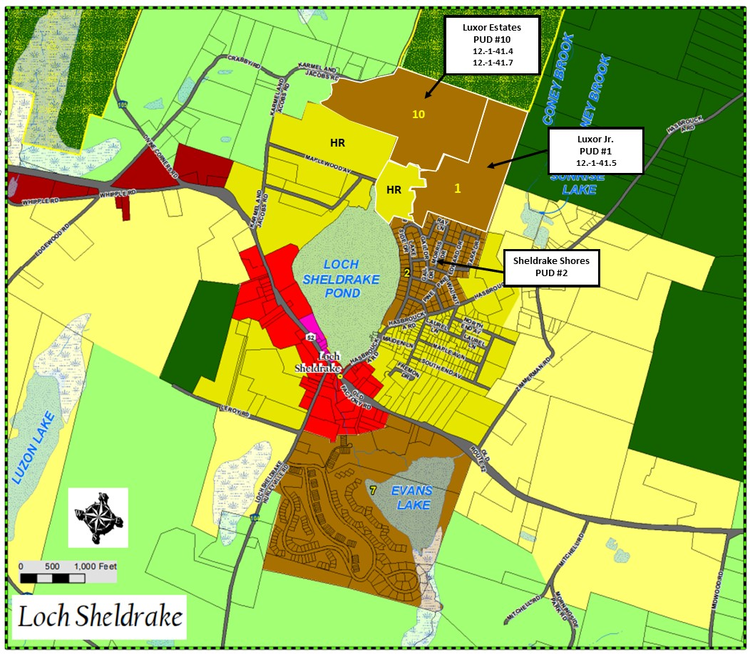

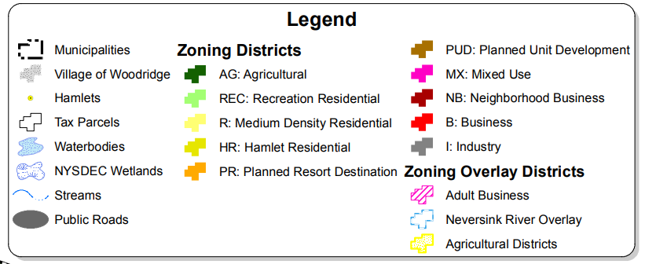
SBL | NUM | STREET ADDRESS | CITY, STATE
12.B-3-9 |  | Maplewood Ave | Loch Sheldrake, NY
12.B-3-8 |  | Maplewood Ave | Loch Sheldrake, NY
12.B-3-7 |  | Buttercup Rd Tr 171B | Loch Sheldrake, NY
12.B-3-1 |  | Buttercup Rd Tr 171B | Loch Sheldrake, NY
12.B-2-8 |  | Buttercup Rd Tr 171B | Loch Sheldrake, NY
12.B-2-7 |  | Buttercup Rd Tr 171B | Loch Sheldrake, NY
12.B-2-6 |  | Buttercup Rd Tr 171B | Loch Sheldrake, NY
12.B-2-5 |  | Buttercup Rd Tr 171B | Loch Sheldrake, NY
12.B-2-2 |  | Aster Rd Tr 171A | Loch Sheldrake, NY
12.B-2-4 | 18 | Aster Rd | Loch Sheldrake, NY
12.B-2-3 | 38 | Aster Rd | Loch Sheldrake, NY
12.B-1-3 | 37 | Aster Rd | Loch Sheldrake, NY
12.B-2-9 |  | Buttercup Rd Tr 171B | Loch Sheldrake, NY
12.B-2-10 |  | Buttercup Rd Tr 171B | Loch Sheldrake, NY
12.B-1-4 |  | Aster Rd Tr 171A | Loch Sheldrake, NY
12.-1-41.2 | 94 | Maplewood Ave | Loch Sheldrake, NY
12.-1-42 | 89 | Maplewood Ave | Loch Sheldrake, NY
12.A-1-2 |  | Aster Rd Tr 171A | Loch Sheldrake, NY
12.A-1-4 | 21 | Aster Rd | Loch Sheldrake, NY
12.A-1-3 |  | Aster Rd Tr 171A | Loch Sheldrake, NY
12.A-1-1 |  | Aster Rd Tr 171A | Loch Sheldrake, NY
12.B-1-1 |  | Aster Rd | Loch Sheldrake, NY
12.B-1-2 | 35 | Aster Rd | Loch Sheldrake, NY
12.B-2-1 | 103 | Maplewood | Loch Sheldrake, NY
12.A-2-2 | 108 | Maplewood Ave | Loch Sheldrake, NY
12.A-2-1 | 24 | Aster Rd | Loch Sheldrake, NY
12.A-2-9 | 20 | Aster Rd | Loch Sheldrake, NY
12.A-2-4 | 4 | Buttercup Ln | Loch Sheldrake, NY
12.A-2-5 | 8 | Buttercup Ln | Loch Sheldrake, NY
12.A-2-3 | 2 | Buttercup Ln | Loch Sheldrake, NY
12.A-3-1 |  | Buttercup Rd Tr 171B | Loch Sheldrake, NY
12.A-3-9 | 13 | Buttercup Ln | Loch Sheldrake, NY
12.A-3-8 |  | Buttercup Rd Tr 171B | Loch Sheldrake, NY
12.A-2-6 | 2 | Aster Rd | Loch Sheldrake, NY
12.A-2-8 | 14 | Aster Rd | Loch Sheldrake, NY
12.A-1-8 |  | Aster Rd Tr 171A | Loch Sheldrake, NY
12.A-1-9 | 69 | Lake Side Dr | Loch Sheldrake, NY
12.A-1-7 | 13 | Aster Rd | Loch Sheldrake, NY
12.A-1-6 |  | Aster Rd | Loch Sheldrake, NY
12.A-1-5 | 19 | Aster Rd | Loch Sheldrake, NY
12.-1-46 | 57 | Maplewood Ave | Loch Sheldrake, NY
12.-1-45 | 61 | Maplewood Ave | Loch Sheldrake, NY
12.-1-43 | 69 | Maplewood Ave | Loch Sheldrake, NY
12.-1-44 | 65 | Maplewood Ave | Loch Sheldrake, NY
12.-1-47 | 53 | Maplewood Ave | Loch Sheldrake, NY
12.-1-48 | 47 | Maplewood Ave | Loch Sheldrake, NY
12.-1-49 | 41 | Maplewood Ave | Loch Sheldrake, NY
12.-1-50 | 35 | Maplewood Ave | Loch Sheldrake, NY
12.-1-51 | 33 | Maplewood Ave | Loch Sheldrake, NY
12.-1-52 | 27 | Maplewood Ave | Loch Sheldrake, NY
12.-1-53 | 21 | Maplewood Ave | Loch Sheldrake, NY
12.-1-55 | 15 | Maplewood Ave | Loch Sheldrake, NY
12.-1-58 | 58 | Karmel-Jacobs Rd | Loch Sheldrake, NY
12.-1-59 | 60 | Karmel & Jacobs Rd | Loch Sheldrake, NY
12.-1-61 |  | Jacobs Rd Tr 58 | Loch Sheldrake, NY
EXHIBIT C

